23.02.21

WALT use reasoning and problem solving skills

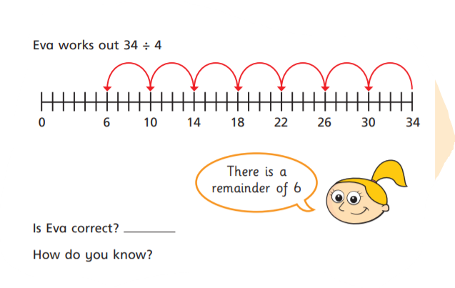

1.

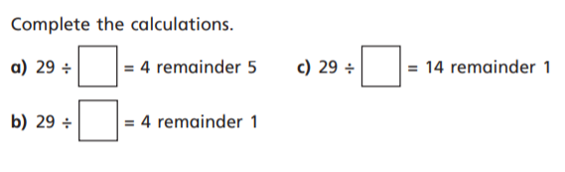

2.

With the questions below, take off the remainder from the number to see how much you have. So, for the first one

29 – 5 equals ?

Then use your times tables facts. So 25 divided by what gives you 4?

4 x ? = 24?

**Answers**

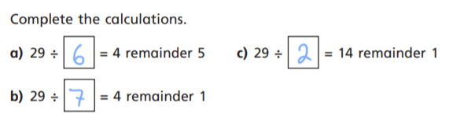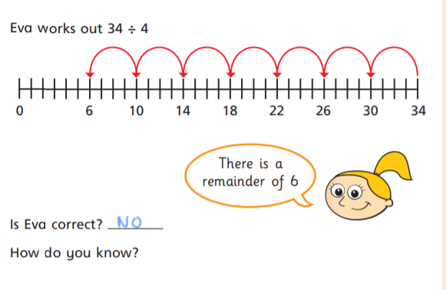

Because you can make one more group of four, so the correct answer is 8 remainder 2