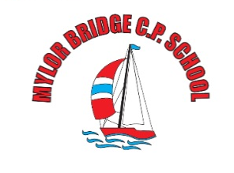
Weekly
Newsletter
email:secretary@mylor-bridge.cornwall.sch.uk

Monday 30th June 2022
Dear Parents/ Carers,

Class teachers for Next Year
We have finalised the details for next year’s classes - please see below:

Class 1 | Mrs Mogridge (M-W) Mrs French (Th-F)
Class 2 | Mr Shainberg
Class 3 | Mrs Wood (M-W) Mrs Sanderson (Th-F)
Class 4 | Mrs Thomas (M-W) Mrs Medlin (Thu-F)
Class 5 | Mr Martin
Class 6 | Mr Collinge

Text Messages from School - ESchools App
We have noticed that a few families are not receiving text message alerts. After much investigation, it appears that there is an updated version of the eschools app – please can you ensure that you have updated the app in order to receive important messages. Thank you.

Sports Day Success
What a great event Sports Day was last Tuesday – Mr Martin and the staff regaled stories of great sportsmanship, super community support, and a fun and enjoyable atmosphere. Thank you to our fantastic PTA who provided refreshments all day.

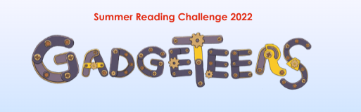
Summer Reading Challenge
We know that our children LOVE reading, but sometimes it is difficult to keep that enthusiasm going over the holidays. This week in assembly we will be visited by the Cornwall Library Service, who are launching this year’s Summer Reading Challenge https://summerreadingchallenge.org.uk/
This is a challenge which you can access at the library in Falmouth, or online in which you set a reading goal to work towards across the summer. The children who achieve their reading goal receive rewards along the way, and those who finish the challenge receive a certificate in assembly.
E-books are available on line, whilst books to borrow are available from local libraries inc. Falmouth library (details below)
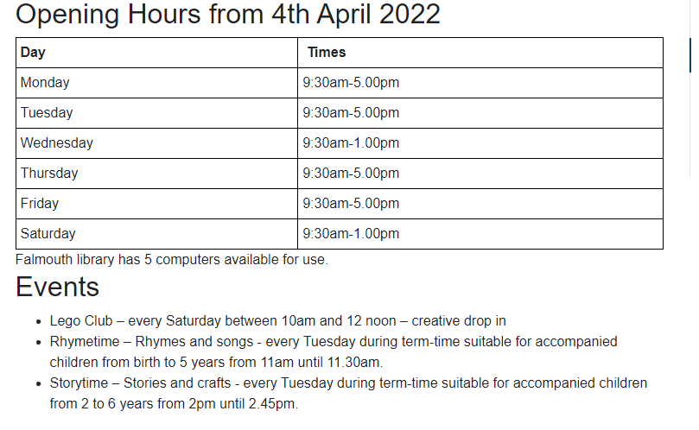

Learning Support
Each week we will be sharing with you some useful resources and websites which support learning here at school.
Last time we looked at Music. This week, our focus is READING
For ideas and ways of engaging your child in some extra-enjoyable Reading at home, why not try:

What to know more about your favourite authors: https://summerreadingchallenge.org.uk/reading-club
Need some ideas to get your child reading https://www.booktrust.org.uk/books-and-reading/tips-and-advice/reading-tips/
Story books to read online https://www.booktrust.org.uk/books-and-reading/have-some-fun/storybooks-and-games/

A few reminders from last week …

School Starting times from September
Due to the government’s commitment that all schools need to offer 32.5 hrs access time each week. School will start at 8:45 am from 6th September 2022. This is a slight change to the opening of the gates at 8:45 am as is the present practise. Please can parents use this half term to practise the new routine of getting to school for 8:45am – this will be statutory from September. Thank you for your help with this.

Leavers’ Assembly
We would like to invite the family of our Y6 Leavers to a Leavers’ Assembly on Friday 22nd July @ 2 pm – to be held outside if the weather is kind to us – alternatively, we will gather in the hall.

Clubs this half term
Please note for Cycling and Running clubs that LAST week is week beginning 27th June.

Intervention with Mrs Hamilton and Mr Wilcox will continue past this date – this is by invite only. Mr Collinge’s Boys’ Writing Group will also continue – by invite only.

PE uniform – from Sept 22
Just a reminder about PE kit for next year:
We will continue to wear PE kit to school on PE days. PE kit from next September will be: black shorts/tracksuit bottoms/ plain black or navy leggings, a plain white T-shirt (logoed if you wish), either a school jumper/ cardigan or a new PE hoody (soon available from Trophy Textiles). Please note Year 6 can use their leavers’ hoodies for their PE kit. These changes will be in place from Sept ‘22.

Making the Most of … Month
The timetable for making the Most of … Month is as follows
Class 1 | Class 2 | Class 3 | Class 4 | Class 5 | Class 6
Reception  Feadon Farm  Wednesday 15th June  Art morning @ school  Thursday 16th June  Year 1 and 2  Beach Trip –  Friday 24th June  Local Nature Walk  Art Builders project – in class | Art morning @ school  Thursday 16th June  Beach Trip  Friday 24th June  Fun and Games @ Mylor Playing Field  Design and Build Project – in class. | Art morning @ School – Thursday 23rd June  Mount Hawke Skate Park –Friday 24th June. (am) Please bring a scooter/ skate board and safety helmets  Falmouth Art Gallery  Thursday 30th June  Cooking in class  Friday 8th July | Eden Project visit Monday 6th June  Fire station Visit Thursday 16th June  Art morning @ School – Thursday 23rd June  Cooking in class Thurs 30th June (TBC) | School Camp  Monday 13th – Wednesday 15th June  Art morning @ School – Thursday 23rd June  Bissoe Bike Trail  Wednesday 29th June – children will need bikes and helmets  Boxing  Date TBC  Surfing 7th Thursday July  Children will need wetsuits/towels/swimming costumes | School Camp  Monday 13th – Wednesday 15th June  Art morning @ School – Thursday 23rd June  Bissoe Bike Trail  Wednesday 29th June - children will need bikes and helmets  Stithians Dam  Thursday 30th June (pm)  Surfing 7th Thursday July  Children will need wetsuits/towels/swimming costumes
Tennis coaching – Date TBC

Have a great week
Vicky Sanderson

Dates for your Diaries
22/7/22 – Last day of term Leaver’s Assembly 2:00 pm 3.15pm finish

INSET Dates for 2021-2022

Monday 25th July 2022 – INSET Day
Tuesday 26th July 2022 (additional Jubilee Bank Holiday for Mylor Bridge CP School)

Return to School
Years 1-6 - Tuesday 6th September at 8:45 am
Reception – from 12th September – see induction letters for details

