Christmas puzzle

On Christmas Eve the children of one family left a note for Santa saying that all the girls would like a puzzle each and all the boys would like a book each. They left Santa this riddle to solve:
The girls have twice as many sisters as brothers and the boys have five times as many sisters as brothers.
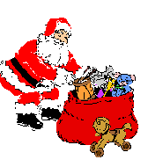
How many puzzles and how many books did Santa leave for the children?

