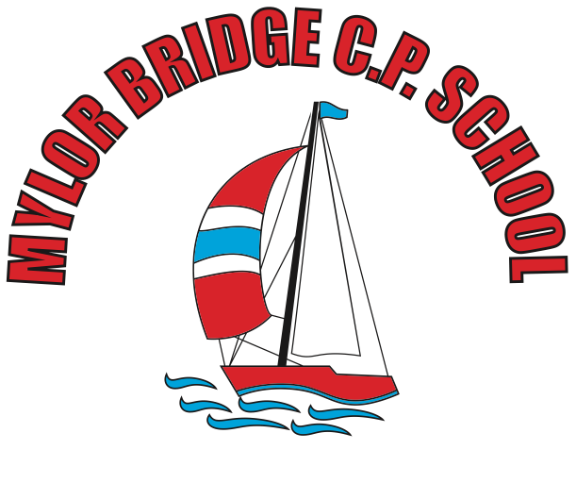
Summer Learning Projects Years 3 & 4 Theme: The Rainforest
English | Reading Task - Read online together about rainforests. Ask your child to take a look at these facts about rainforests to get started! Can they create a rainforest quiz?  Writing Task - Ask your child to research how humans are destroying the rainforest. Get them to write an information report about this. Can they include maps that demonstrate how large the rainforests were compared to now? Include an introduction, 3 or 4 ways that rainforests are being destroyed and a conclusion.
Maths | Maths - Play this rainforest coordinates game
Topic | The project this week aims to provide opportunities for your child to learn more about the world’s rainforests. Learning may focus on the plants, animals and insects that inhabit the rainforest, food that originates there and weather patterns. It could look at plants and animals that can be found in the garden too.  Amazing Animals - Ask your child to think about the following: How many different types of animals live in rainforests? Can they name any? What is their diet like? How do they hunt for their prey or hide from predators? Look at these 11 amazing rainforest animals. Encourage your child to choose one of the animals and create a poster all about them.  Layers of the Rainforest- Take a look at this information with your child, all about the layers of the rainforest. Ask your child to try creating their own diagram showing the layers of the rainforest and the animals you can find in each layer. Your child could cut and stick pictures, paint or draw! Can your child categorise the animals?  Roar!- Have a go at this forest themed GoNoodle! Finished? Ask your child to try making up their own rainforest-themed dance routine to  the same song - they could pretend to be a different animal for each dance move!  One Step at a Time - Talk to family members about the deforestation of rainforests and think about how we could help by taking small steps at home. This article should help get them started! Can your child record their very own advert encouraging people to reduce, reuse, recycle? Encourage them to think about the impact on the environment, animals and their habitats, global warming and the tribes that occupy the rainforests. Alternatively, they could write a jingle about the benefits of recycling and perform this to the family.  The Problem with Palm Oil - Take a look at the Greenpeace website and find out about the effects of palm oil on our planet. Discuss with your child how this affects animals around the world. Ask your child to identify all of the foods in the kitchen that contain palm oil. Can they suggest alternatives for your next shop?

