***Year 6 – Rivers Knowledge Organiser***

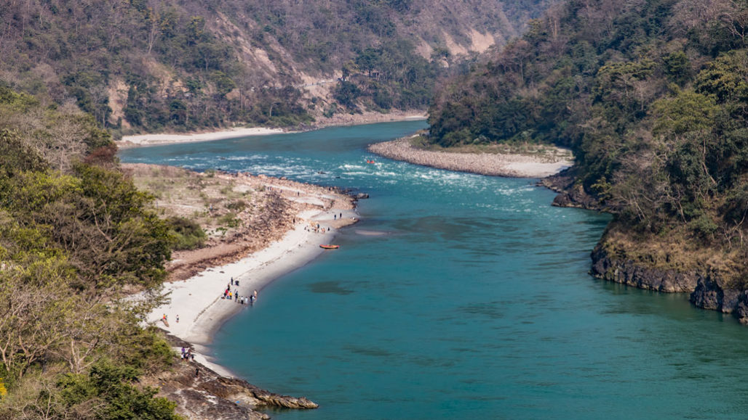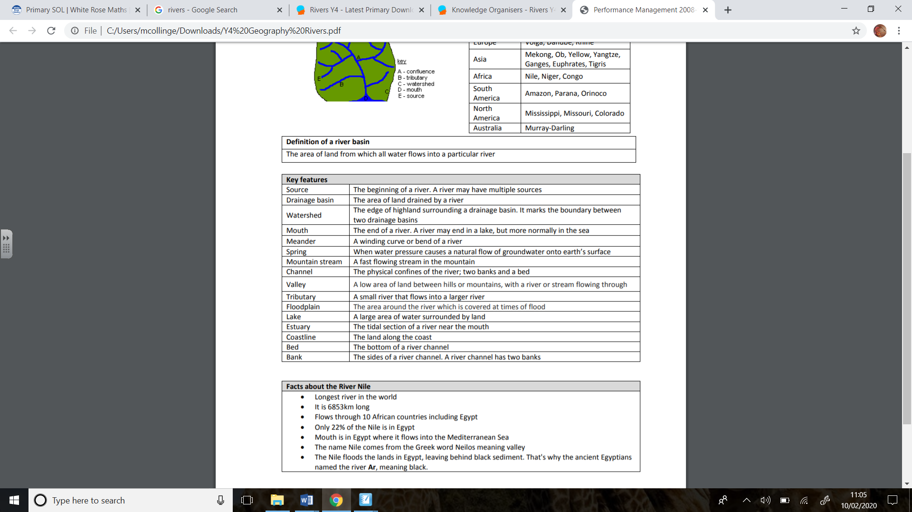

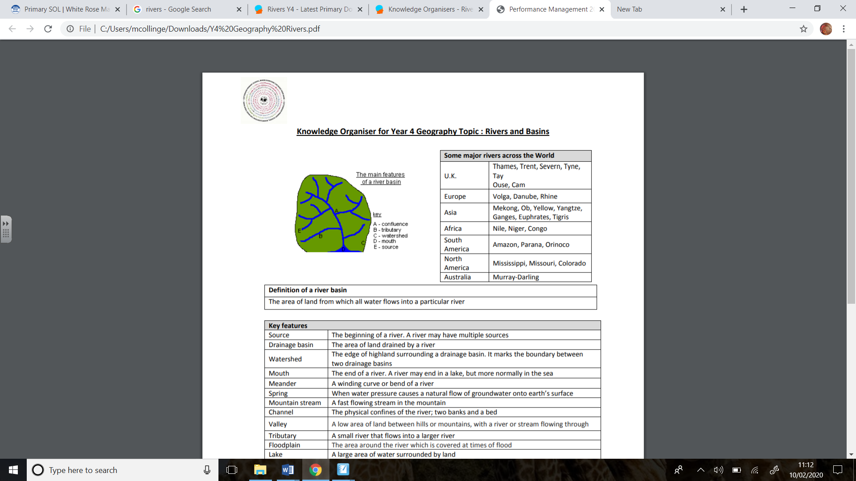

***Key Questions***

Where do rivers begin and end?

What are some of the longest rivers in the world?

What are the differences between the upper, middle and lower course?

How do rivers change in time?