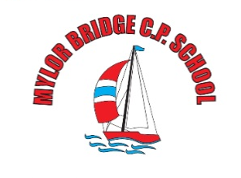
Weekly
Newsletter
email:secretary@mylor-bridge.cornwall.sch.uk

Monday 25t^{h} May 2020
Dear Parents,

As you know, this is half term so there will be no work set for your children this week. If you are struggling for ideas to keep the children occupied whilst you stay socially distanced from friends and family – see https://www.twinkl.co.uk/blog/top-10-half-term-activities-for-kids
https://www.forbes.com/sites/tarahaelle/2020/03/15/101-ideas-to-keep-your-kids-busy-during-coronavirus-closures/#5e18f4f774a4

Also, some further information regarding returning to school:

Take care and stay safe,

Vicky Sanderson

