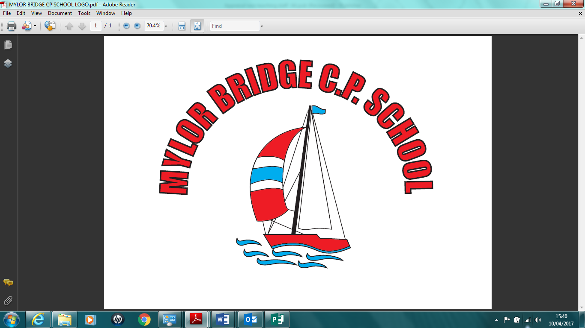
Mylor Bridge School
Complaints Policy
School Complaints Officer Name:
Executive Headteacher
School Complaints Officer Contact Details:
Mylor Bridge School , Comfort Road, Mylor Bridge

Introduction

  - Mylor Bridge School welcomes feedback on the services it provides. Should anyone be unhappy with any aspect of the school, it is important that the school learns about this.

  - As schools have legal responsibilities to deal with many general complaints, this policy outlines how such complaints will be dealt with by the school. Some issues should not be dealt with by the school and these are listed in Appendix 1.

  - Children as well as parents have legitimate rights to express concerns or to make complaints, but maturity and understanding will vary from child to child. Therefore, the school will consider a complaint on its merits. Please note that a person does not have to be a parent or a pupil of the school to make a complaint. Please also note that anonymous complaints cannot be examined under a complaints procedure.

  - Governors have an important role to play in considering complaints. However, it is important for parents to understand that individual governors must not investigate complaints outside this procedure. All complaints should be addressed to the school complaints officer in the first instance whose details are recorded above.

  - Please note that should a complaint, informal or formal, reveal an issue for which other procedures exist (for example, child protection) then it will be dealt with under those procedures rather than as a complaint
Stage 1 - Informal Resolution

  - Many enquiries and concerns can be dealt with satisfactorily by the class

teacher, the headteacher or other members of staff without the need to resort to a formal procedure. The school values informal meetings and discussions.

  - There is no suggested time-scale for resolution at this stage given the importance of dialogue through informal discussion although it would be expected that most issues would be resolved within 10 school days. Should this informal stage require more time then the school will inform the complainant of this in writing as soon as this is known.

  - Please note that 'in writing' means a letter or an email. The final report of any formal investigation will be sent in paper form.

  - Should the face to face discussions appear unlikely to resolve matters, either party may initiate a move to the next stage (Stage 2 below) of the procedure. A copy of the school's complaints policy will be forwarded to the complainant at this stage if it has not been provided as part of Stage 1
Stage 2 - Formal Written Complaints

  - The complainant should set out the precise nature of the complaint on the form provided and return this to the complaints officer. The complainant should keep a copy of this form and all other relevant correspondence
  - Should a complaint be about a general matter, the complaints officer may be able to respond immediately, e.g. if it only requires an explanation of school policy. For complaints that relate to specific actions or events, there is likely to be a need for further investigation in order to clarify the facts. The complaints officer or their nominee will normally undertake this investigation.

  - However, if in the early stages of the investigation, the complaints officer considers that the complaint is best dealt with at Stage 3, it will be passed to the chair of governors (or to the clerk to the governing body for the chair's attention) and the complainant informed of this action without delay.

  - Should the complaints officer, the headteacher or a governor be the subject of a complaint, these will be dealt with under Stage 3 below. The

complainant should send the form directly to the chair of governors (or to the clerk to the governing body for the chair's attention) c/o the school marking the envelope 'private and confidential'.

  - Should the chair of governors be the subject of a complaint, the complainant should send the form directly to the vice-chair of governors (or to the clerk to the governing body for the vice-chair's attention) c/o the school marking the envelope 'private and confidential'.

  - All formal complaints will be acknowledged within 5 school days of receipt.

  - Investigations at this stage should normally be completed within 20 school days of receipt of the complaint, unless there are circumstances that require a longer investigatory period. The complainant will be informed in writing should more time be required
  - The school will aim to send a formal written response within 5 school days of the completion of the investigation. This gives a target of 5 school weeks for the completion of this stage of the procedure.

  - Following the stage 2 investigation, the complaints officer will decide on one of two outcomes:-
- 1. Recommend that appropriate remedial action necessary to resolve the complaint be undertaken, or
- 2. Confirm that all internal investigative measures have been exhausted and uphold the original informal response if this had occurred.
  - The decision is confidential to the complainant and to the governing body.
  - The complainant may take the complaint further if they are unhappy with the Stage 2 outcome by giving notice of their intention within 10 school days of their receipt of the formal outcome. This notice should be made in writing to the chair of governors (or to the clerk to the governing body for the chair's attention) c/o the school marking the envelope 'private and confidential'

Stage 3 - The Governing Body
  - Where the complaints officer is unable to resolve a complaint to the satisfaction of the complainant or where there is a complaint against the complaints officer, the headteacher or a governor, the complainant should write to the chair of governors (or to the clerk to the governing body for the chair's

attention) c/o the school marking the envelope 'private and confidential' including copies of all relevant documents.

  - Should the chair of governors be the subject of a complaint, the complainant should send the form directly to the vice-chair of governors (or to the clerk to the governing body for the vice-chair's attention) c/o the school marking the envelope 'private and confidential'.

  - A panel of three governors must be convened by the chair (or vice-chair) of governors to investigate the complaint.

  - All formal complaints will be acknowledged within 5 school days of receipt.

  - Investigations at this stage should normally be completed within 20 school days of receipt of the complaint, unless there are circumstances that require a longer investigatory period. The complainant will be informed in writing should more time be required.

  - The school will aim to send a formal written response within 5 school days of the completion of the investigation.

  - This gives a target of 5 school weeks for the completion of this stage of the procedure.

  - Following the stage 3 investigation, the panel will decide on one of two outcomes:-
- 1. Recommend that appropriate remedial action necessary to resolve the complaint be undertaken, or
- 2. Confirm that all internal investigative measures have been exhausted and uphold the original response.
  - The decision is confidential to the complainant and to the governing body.
What can I do if I am not happy with the school and governing body’s responses? Local authorities are responsible for education in their area, and may be able to offer guidance and advice about state-funded schools. These include community schools, foundation schools, voluntary aided and voluntary controlled schools (but not academies). Your council’s website will contain information about the number and type of schools in its area .Mylor Bridge is a state funded school.
If your complaint is unresolved and you feel that the school has behaved

unreasonably about your concerns, you can write to the Secretary of State for Education. Write to:
The Secretary of State Department for Education Sanctuary Buildings Great Smith Street
London SW1P 3BT Telephone: 0870 000 2288

Mylor Bridge School complaint form

Please complete and return to: Vicky Sanderson – Headteacher who will acknowledge receipt and explain what action will be taken.

Your name: Pupil’s name:
Your relationship to the pupil: Address:

Postcode:
Day time telephone number: Evening telephone number:

Please give details of your complaint.

What action, if any, have you already taken to try and resolve your complaint. (Who did you speak to and what was the response)?

What actions do you feel might resolve the problem at this stage?

Are you attaching any paperwork? If so, please give details.

Signature: Date:
Official use

Date acknowledgement sent: By who:

Complaint referred to: Date:

Complaints areas where the Children Service Authority (CSA) or others have responsibility (appendix 1)

The following areas are those that should not be addressed through the school complaints policy:

- Complaints about the curriculum and the provision of collective worship and religious education.

- Complaints about the CSA's assessment of a child's special educational needs.

- Appeals against refusal to admit a child to the parent's preferred school.

- Appeals against exclusions (although an appeal to the governing body will be involved in the earlier stages).
Details of the procedures for these complaints are available from the CSA. Children, Schools and Families
New County Hall, Truro
Cornwall TR1 3AY
Please note that should a complaint, informal or formal, reveal an issue for which the above applies or where other internal procedures exist (for example, child protection) then it will be dealt with under these procedures rather than as a complaint

Agreed on 12.6.17

Signed: Mr P Dale CoG

