**Rainforest Locations**

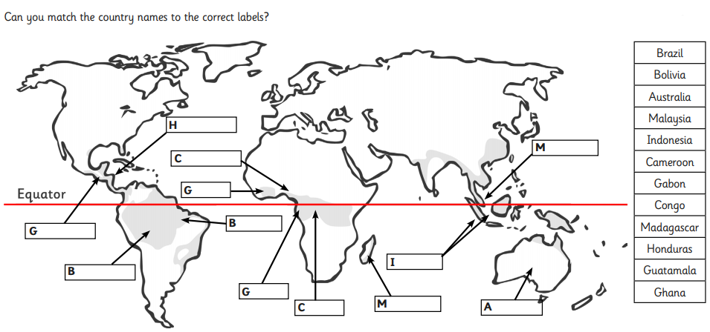

Match the country names to the correct labels