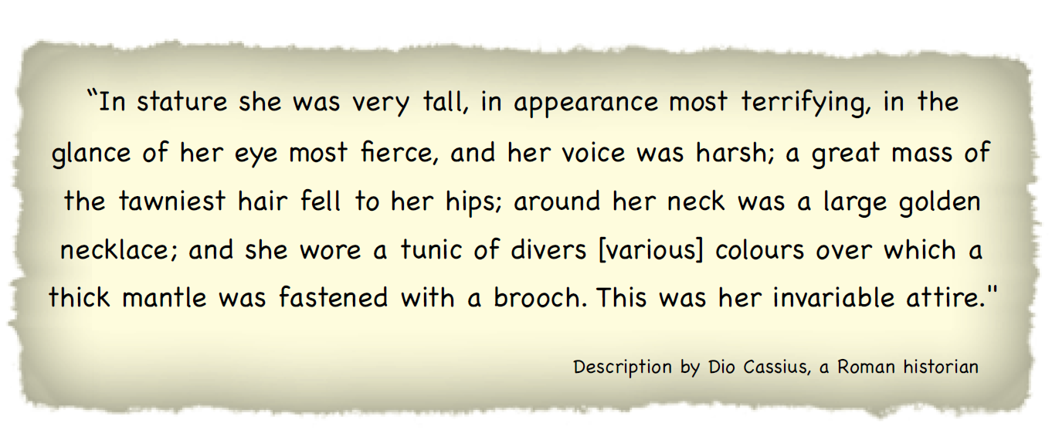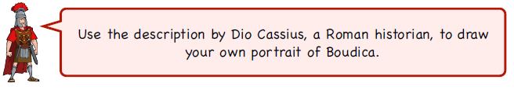WALT use secondary sources to draw Boudica