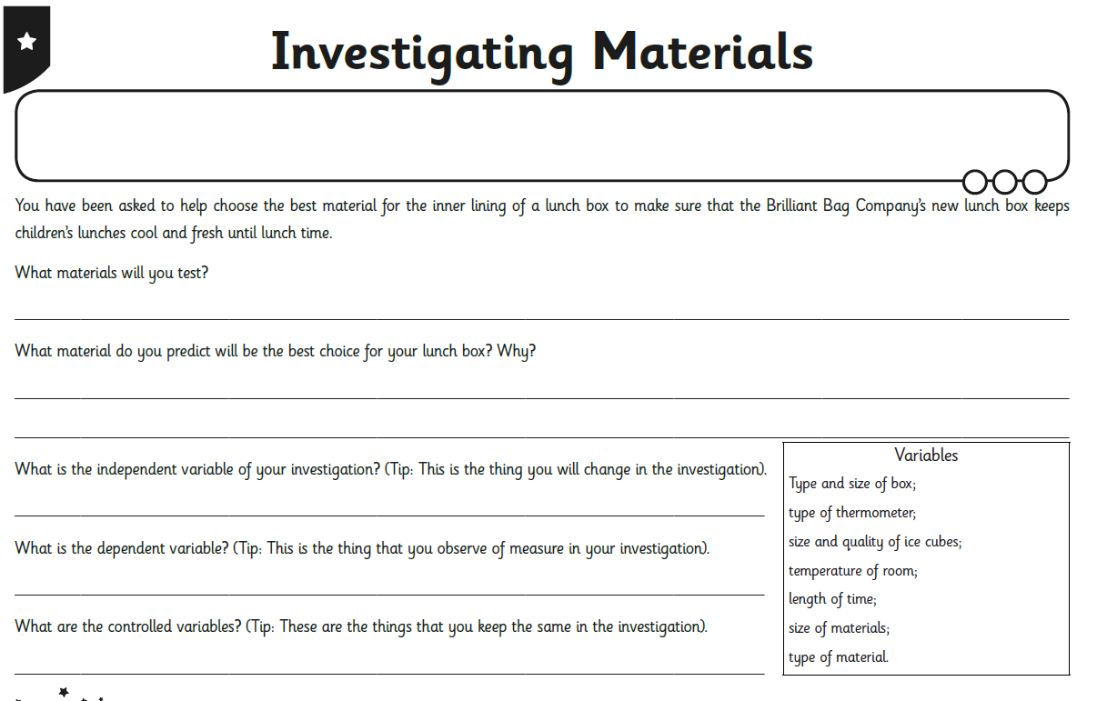

Fill in the results in to this table. Each time pour the water from each material in to a different container then measure using a measuring jug. Do not pour away any of your water.

Material | Starting amount of Ice cubes | Liquid drained after 5 minutes | Liquid drained after 15 minutes | Liquid drained after 25  minutes | Liquid drained after 30 minutes

