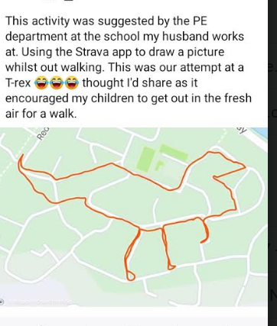
I saw this on Facebook and thought it was a cool idea! What shapes or animals could you make?!

