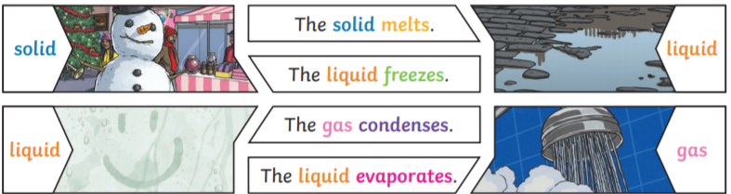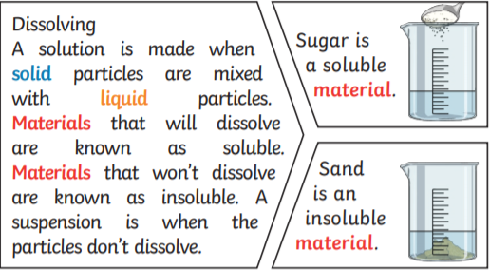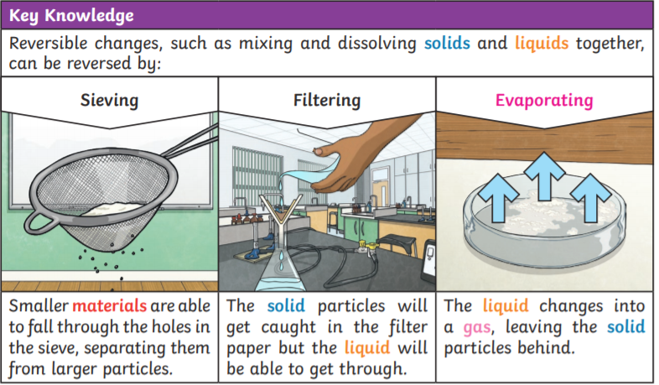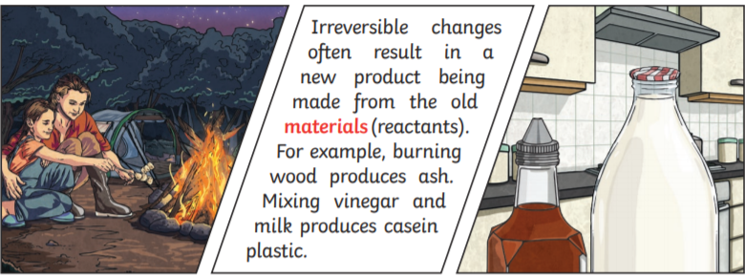

Changes of state

**Key questions**

1. **Name two natural materials.**
2. **Name two synthetic materials.**
3. **What does flexible and absorbent mean?**
4. **Name some materials that will dissolve in water.**
5. **What does the word insoluble mean?**
6. **What does the word solution mean?**
7. **How could you make something dissolve faster?**
8. **If I wanted to get salt back after it was dissolved in water, what could I do?**
9. **Name some examples of irreversible changes.**
10. **If you wanted to keep something warm, what would be a good material to wrap it in?**
11. **What is the process called from which liquid changes state in to a gas?**
12. **What is the process called when a liquid is cooled and it changes state?**

Disolving

Irreversible Changes

Reversible Changes

**Key Vocabulary**

**Conductor – A material or device which allows heat or electricity to carry through**

**Dissolve – When something solid mixes with a liquid and becomes part of the liquid**

**Evaporation – The process of turning from liquid to vapour**

**Flexible – Capable of bending easily without breaking**

**Synthetic – human made**

**Natural – natural in nature**

**Gas – An air-like fluid substance which expands freely to fill any space available**

**Insulator – A substance which does not readily allow the passage of heat or sound**

**Irreversible – Cannot be reversed back to its original state**

**Liquid – A substance that flows freely but can be measured by volume e.g. water or oil**

**Magnetic – Capabale of being magnetised or attracted by a magnet**

**Material – The matter from which a thing is or can be made from**

**Opaque – Not able to be seen through, not transparent**

**Reversible – Able to be reversed back to its original state**

**Solid – Firm and stable in shape, not a liquid or fluid**

**Soluble – Able to be dissolved, especially in water**

**Thermal – Relating to heat**

**Transparent – Allows light to pass through so that objects behind can be seen**

**Properties and changes of materials**

**Year 5– Knowledge Organiser**

**Materials**