Science
Knowledge Organiser: Animals and Humans
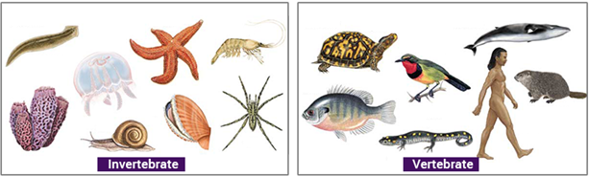
Key Vocabulary
Skeleton | The bony frame work of the body which provides support, shape and protection
Vertebrate | An animal with a spinal cord/ backbone
Invertebrate | An animal WITHOUT a spinal cord/ backbone
Exoskeleton | A skeleton on the outside of the body – called shells.
Muscle | Part of the body that allows movements
Joint | Where two bones meet, allowing for movement
Protect | One of the functions of the skeleton is to protect internal organs
Support | One of the functions of the skeleton is to support the body.
Movement | One of the functions of the skeleton is to allow the body to move.
Key Questions:
- How do we classify animals according to what they eat?
- What is a balanced diet?
- What is the purpose of our skeleton?
- How do we classify animals according to their skeletons?
- How do animal movements compare to human movements?
- How do muscles work?

Human Skeleton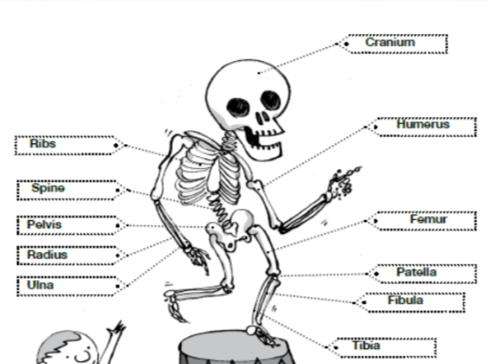
Identify that animals, including humans, need the right types and amounts of nutrition; that they cannot make their own food and they get nutrition from what they eat
Identify that humans and some animals have skeletons and muscles for support, protection and movement. (N.C)

