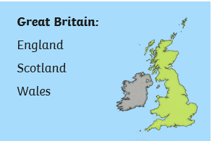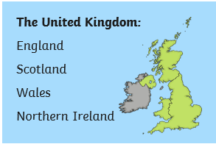

**Geography Mapping Skills**

**United Kingdom of Great Britain and Northern Ireland**

**Key Vocabulary**

* United Kingdom, England, Scotland, Wales, Northern Ireland, Great Britain, London, Edinburgh, Cardiff, Belfast, capital,

|  |  |  |  |
| --- | --- | --- | --- |
| * River, sea, North Sea, English Channel, * Irish Sea, Atlantic Ocean, River Thames,  |  |  |  | | --- | --- | --- | | |  |  | | --- | --- | | * River Severn, River Tay, River Bann. * County, country town.  |  | | --- | | * Mountain, hill, range, peak, height, legend. * City of London, Greater London, population, * growth, immigration, trading, finance, * suburbs, migrants | | | |

**Key Questions**

* Which countries make up the United Kingdom? What are their capital cities?
* What are the sea surrounding the UK called?
* What are some of the main rivers in the UK called?
* What are some of the counties in England called? Where is Cornwall?
* What are some of the highest peaks in the UK called?
* How has London changed since AD43?
* Where did some immigrants to the UK come from?

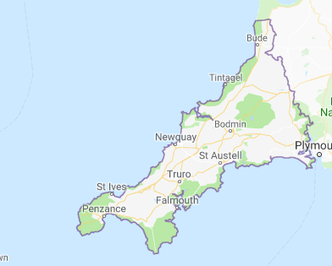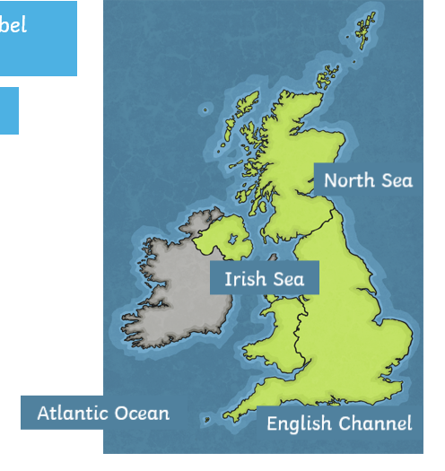

Our county: Cornwall

Seas and oceans surrounding the UK

|  |
| --- |
| . |