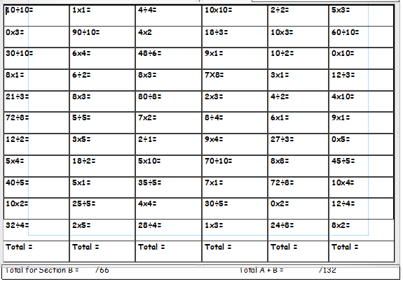
Snow Day – Maths Y3 and 4

Maths challenge
https://nrich.maths.org/141

