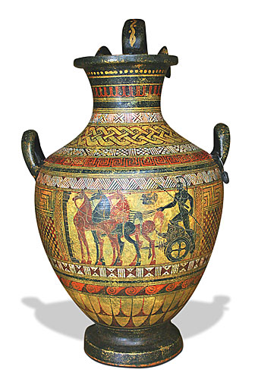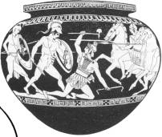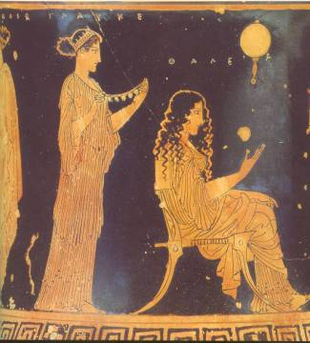**WALT use Greek pottery to make inferences and deductions about Greek life.**

**What story do you think this pot shows?**

**Look at this painting on the Greek vase. What does it tell you about Greek warfare?**

**Look at this painting from a Greek vase. What does it tell you about Greek clothes, hairstyles, furniture and pottery decoration?**