Roman Chariot
Design Brief
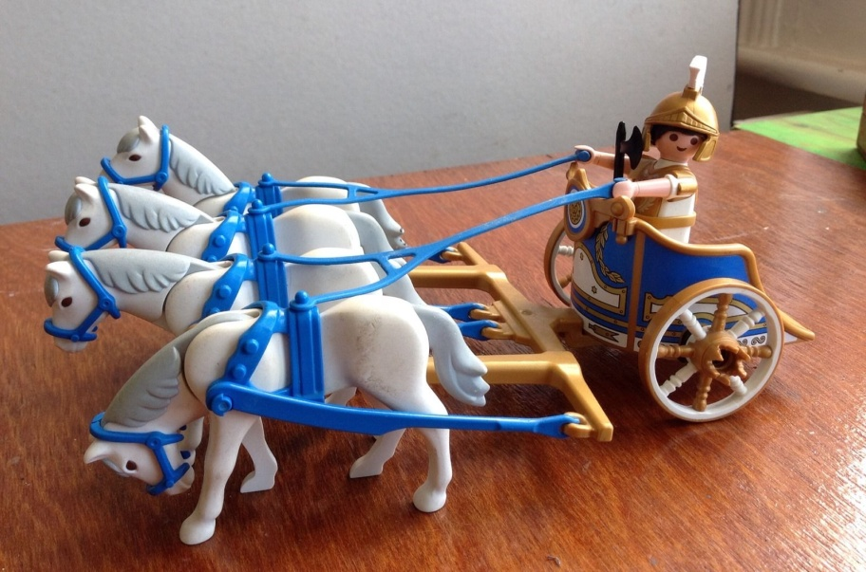
To design, make and evaluate a Roman Chariot, which can be pulled by 1 Playmobile-sized horse.

Design Ideas

Materials needed

Final Product

Evaluation

- What are you pleased with? Why?
- What would you change? Why?
- What did you have to change? Why?
- Did it fulfil the design brief?

________________________________________________________________________________________________________________________________________________________________________________________________________________________________________________________________________________________________________________________________________________________________________________________________________________________________________________________________________________________________________________________________________________________________________________________________________________________________________________________________________________________________
________________________________________________________

