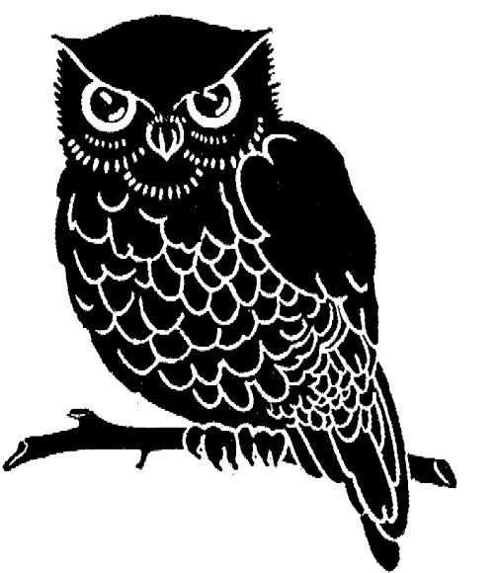A

35 | 40 ÷ 5 =
36 | 8 x 6 =
37 | 12 ÷ 3 =
38 | 25 ÷ 5 =
39 | 73 - 44
40 | 12 ÷ 6 =
41 | 10 ÷ 2 =
42 | 28 ÷ 4 =
43 | 74 + 46
44 | 3 x 9 =
45 | 33 ÷ 11 =
46 | 5 x 1 =
47 | 2 x 4 =
48 | 121 ÷ 11 =
49 | 61 -32
50 | 6 x 9 =
51 | 6 x 6 =
52 | 7 x 5 =
53 | 5 x 7 =
54 | 10 x 4 =
55 | 53 + 89
56 | 108 ÷ 12 =
57 | 6 x 2 =
58 | 24 ÷ 12 =
59 | 60 ÷ 6 =
60 | 6 x 12 =
61 | 9 x 3 =
62 | 45 ÷ 5 =
63 | 7 x 3 =
64 | 9 x 5 =
65 | 81 ÷ 9 =
66 | 99 +72
67 | 5 x 4 =
1 | 20 ÷ 2 =
2 | 18 ÷ 6 =
3 | 34 + 72
4 | 10 x 10 =
5 | 36 ÷ 6 =
6 | 73 - 54
7 | 4 x 6 =
8 | 6 x 7 =
9 | 3 x 1 =
10 | 20 ÷ 4 =
11 | 91 +24
12 | 14 ÷ 2 =
13 | 5 x 11 =
14 | 8 x 9 =
15 | 75 - 39
16 | 10 x 9 =
17 | 2 x 6 =
18 | 99 ÷ 11 =
19 | 6 x 11 =
20 | 16 ÷ 2 =
21 | 63 + 78
22 | 8 x 11 =
23 | 50 ÷ 5 =
24 | 7 x 12 =
25 | 44 ÷ 11 =
26 | 35 ÷ 5 =
27 | 70 - 21
28 | 8 x 5 =
29 | 36 ÷ 12 =
30 | 34 + 92
31 | 9 x 12 =
32 | 48 ÷ 8 =
33 | 9 x 9 =
34 | 48 ÷ 12 =
68 | 8 x 8 =
69 | 16 ÷ 4 =
70 | 101 - 45
71 | 60 ÷ 5 =
72 | 21 ÷ 3 =
73 | 4 x 9 =
74 | 4 x 8 =
75 | 96 ÷ 12 =
76 | 6 x 1 =
77 | 85 + 42
78 | 5 x 3 =
79 | 3 x 5 =
80 | 6 x 8 =
81 | 2 x 2 =
82 | 77 - 43
83 | 36 ÷ 9 =
84 | 10 x 2 =
85 | 40 ÷ 4 =
86 | 61 + 99
87 | 5 x 8 =
88 | 24 ÷ 6 =
89 | 7 x 9 =
90 | 8 x 4 =
91 | 6 x 5 =
92 | 32 + 48
93 | 64 ÷ 8 =
94 | 56 ÷ 8 =
95 | 21 ÷ 7 =
96 | 132 ÷ 11 =
97 | 64 - 39
98 | 8 x 3 =
99 | 90 ÷ 9 =
100 | 70 ÷ 7 =

