Music Policy
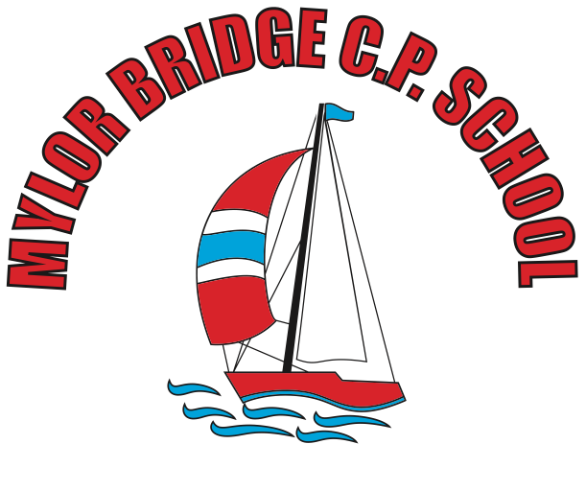

September 2019

Our Vision
At Mylor Bridge School, we aim to provide all our children the opportunity to fulfil and exceed their potential within Music. We have various opportunities for the children to learn, perform and thrive in Music in each academic year.
These are the aims of the National Curriculum (2014). At our school, we believe it is pivotal for children to have the opportunity to learn how to listen to, appreciate, perform and create music. It is a means of communicating, expression and understanding the world around them.
Our school objectives are as follows:
- Know and understand how to make sounds and how they can be assembled together
- Appreciate and know different instruments make music
- Understand how music can be written down and transcribed
- Know how time and place influences its music
- Developing skills in listening, composing, recording and performance of music.
Additional Music Tuition
At Mylor Bridge School, we have tuition in guitar, piano, violin, brass and woodwind instruments. These are all taught by peripatetic teachers who come in from the Cornwall Music Trust to work with our children.
Visits and Performances
Throughout the academic year, there are many opportunities for the children to perform. These are listed below:
- Christmas Plays –before each performance, the children who are learning musical instruments have a chance to perform for the parents. The audience is usually around 100 people. We liaise with the instrumental teachers so they can help the children to prepare a piece to perform for these occasions.
- Easter Concert – each year, we hold a concert at our local village hall. This is usually an hour in duration and celebrates all aspects of music at Mylor Bridge School. We have had former pupils come back and perform, Key Stage 1 and 2 students, parents who work in the music industry and teachers who have played in these events. It is also allows children to perform with a full PA system on a stage before an audience of over 100.
- Year 6 Leavers’ Concert – in 2019, we held the first Year 6 concert for the students leaving the school. This is held in the school hall and allows the children the opportunity to perform one last time and bid farewell to the school.
- Singing/Class assemblies – every term, each class holds a class assembly which enables musicians in each class another chance to perform for their peers. We hold a weekly singing assembly for the whole school where the child sing together. We often have musicians performing as children are walking in and out of assemblies too.
- CAPA – the Creative Arts Primary Academy (CAPA) is an ensemble consisting of children of various local primary schools.
- Fal Strings Orchestra – we host a weekly rehearsal for the Fal Strings Orchestra (of which some of our children attend) who go on to perform in various different concerts throughout the year.
- Songfest – each year, a group of our pupils partake in Songfest, which is a performance of songs from a particular genre or theme. In 2019, it was based around famous theatre songs. This has been pitched at an Upper Key Stage 2 level for our older students.
As part of our appreciation of music, each half term, we focus on a different genre of music and at the end of that half term we host a concert with a professional musician specialising in that genre come in and perform.
Planning and Assessment
At our school, we follow the Charanga scheme. This allows teachers the opportunity to informally assess the children throughout lessons. Following a performance or upon completion of a piece of work, teachers can give oral or written feedback as necessary to inform future progress. As the children progress through the school, they are encouraged to be more self-critical.
Roles and Responsibilities
Each class teacher is responsible for the delivery of music lessons. In order to keep up to date with current changes or curriculum developments, the subject lead should report to the staff to ensure we are delivering the highest quality lessons we can for our students.
Resources
We have a variety of musical instruments at school including keyboards, guitars and a range of percussion instruments. We check the quality and condition of the instruments each year and upgrade them when we can.
Fundraising
Working with parent volunteers, some of our concerts and performances are ticketed in a bid to raise funds to update and improve instruments and resources for the school.

