Settlements change in terms of their shape, function, land use and the type of people who live in them over time.

Firstly, the land use of the village has changed. For example in 1980 the land was used for __________________ and _______________________.

By 2010 it was used for other things as well such as _____________________ and a ________________ park. This shows the area has become more popular with __________________.

Secondly, the shape has changed. For example the village has _______________ in size. This is because by 2010 a lot more_____________________ have been built.

___________________________________________________________________

These have been built because_______________________________

__________________________________________________________________

Thirdly, the function has changed. For example in 1980 the main function of the settlement was a place to _________.

Evidence can be seen of this from_____________________________

Then by 2010 the function had changed to a place to live as well as a place for tourists.

Evidence of this can be seen from the ______________ homes and the ____________ museum,

Lastly, the people who live in the settlement would have changed. For in 1980 the people who lived there probably would have been ______________________________. By 2010 the people are more likely to be ______________________________.

This is because__________________________________________________

___________________________________________________________________

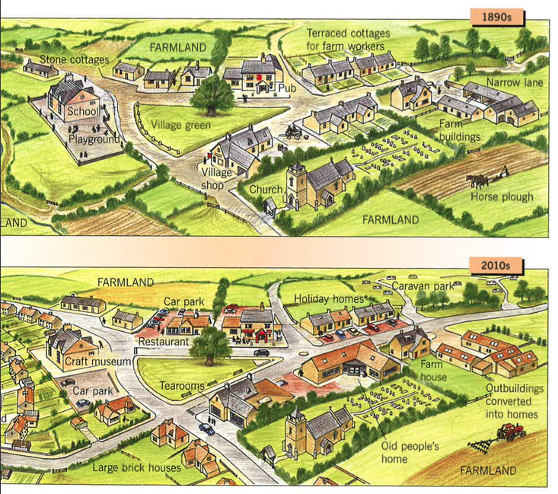

**Key words**

Farming agriculture caravan craft homes car parks grown live holiday tourists housing Farmers in the tourist industry.