The Modern Olympic Games

The modern Olympics is an opportunity for people from all over the globe to come together for a special sporting event. Athletes who take part can compete in a range of over 400 different events. People from all over the world have an equal chance to compete in the events including the Paralympics. The Olympics: Summer, Winter, and Paralympics are held every four years with the hope they can introduce world peace though world sport. If you want to find out more about the modern Olympics, read on.

When and where were the first modern Olympics held?
The first modern Olympics were held in Athens, Greece on 6th April 1896. The International Olympic Committee (IOC) was established in 1894. Pierre de Coubertin was the person who created the modern Olympics. He was a French nobleman who was keen on religious sports. Pierre de Coubertin was born in 1863 in the French capital, Paris. When he was young, he shone at most sports at his school which lead him to be a very keen sportsman. As he grew older his love for sport grew immensely and he formed a passionate belief that sport could change the world. The modern Olympics has lasted for over a century and lives to this very day. Currently we are waiting for the 2021 Tokyo Olympics which have already been postponed once due to the Worldwide Coronavirus Pandemic.

Who can take part in the Modern Olympics?
In every country there is a National Olympic Committee who represent their Nation at the Olympic games and who are responsible for selecting the athletes they wish to take part, creating the National Team. Each sport has a team of selectors who attend National competitions and through observing the athletes make their decisions. Many hours of gruelling training and competition have led to these individuals being considered for selection. The values of the Olympic movement include contributing to building a peaceful and better world by educating the young through sport. Practising without discrimination. Everyone who is involved with the games must have a mutual understanding of the philosophy behind them and take part with a spirit of friendship, solidarity, and fair play.

What types of sports are evident at the Olympic games?
If you wanted to take part in the Ancient Olympic Games there were only a few events in which you could participate, however, the modern Olympics have developed so much that, now, there is even a Winter Olympics and a Paralympics (alternate every two years with the Summer Olympics) where most of the events take place on snow or ice. The first ever recorded Olympic games were held in Olympia, Greece in 776 BC. They took place until 396 AD when the Greek King of the time, called Theadiphadies, decided that he wanted people to celebrate him rather than the Greek Gods. He decided that they should not honour Zeus but him, so he destroyed the temple of Zeus and the Ancient Olympics were never held again till the modern Olympics. Ancient Olympics consisted of only one race which was the length of the stadium about 180-240 meters. Gradually events were added to the ancient Olympics such as boxing, wrestling, discus, long jump, swimming, and javelin. Only young men could take part in the events preparing them for battle. The reason why the modern Olympics have so many events compared to the Ancient Olympics is because the number of Athletes participating has increased so dramatically throughout the years.

Did you know?
In the first modern Olympics, the swimming events took place in the sea or in the river.
Did you know?
In the ancient Olympics women were not allowed to compete in the events and married women were not even allowed to watch the athletes.
Did you know?
In the Ancient Olympics there was only around 20 events and in the modern there is over 400 different events.
What prize would you get if you win?
In the beginning, of the ancient Olympics the winners were awarded a crown of olive wreaths and a silver medal and the runners up were given a laurel wreath the people who came first, second or third are called an Olympiad! In the modern days first gets a gold medal and a crown of olive wreaths, second was awarded a silver medal and a laurel wreath and third had a bronze medal and another laurel wreath. The traditional gold, silver and bronze medals were not established until 1904.
As a result of COVID-19, the Tokyo Olympics 2020 were postponed to 2021, we hope that this year they will not be postponed to 2022. Unfortunately, since the cases have been rising immensely it seems very unlikely it will go forth this year, but we keep our fingers crossed! The latest news from Japan states that they are still hoping to hold the games this summer, however at the moment there is a state of emergency linked to the Covid-19 cases increasing. When these games are eventually held, they will symbolise the triumph of humanity over the virus. We cannot wait!
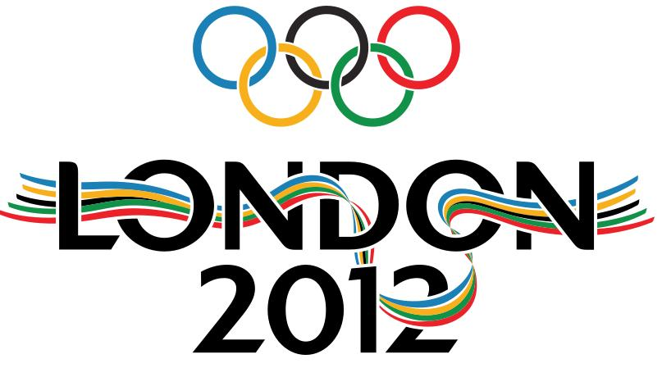
This Photo by Unknown Author is licensed under CC BY
(Our most successful year in the Olympics in recent times.)

