Unit – Leisure and Entertainment (Britain in the 20th Century)
Week 1 | Week 2 | Week 3 | Week 4 | Week 5 | Week 6
WALT: Know how cinema changed throughout the 20th century | WALT: Know how sport has changed throughout the 20th century | WALT: Understand how the lives of young people were different in the 1960s to how they are today | WALT: Know how the holiday industry boomed during the 1930s | WALT: Understand how and why television has become such a popular leisure activity | WALT: Know how changes in technology during the 20th century has drastically changed our lives today
Key Vocabulary
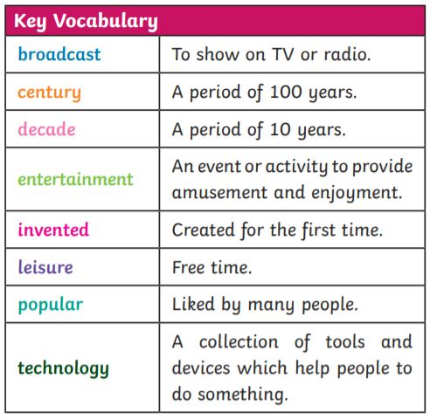
Milestone Indicator
• Use sources of evidence to deduce information about the past.
• Select suitable sources of evidence, giving reasons for choices.
• Understand that no single source of evidence gives the full answer to questions about the past.
• Refine lines of enquiry as appropriate.
• Describe the main changes in a period of history (using terms such as: social, religious, political, technological and cultural).
• Identify periods of rapid change in history and contrast them with times of relatively little change.
• Understand the concepts of continuity and change over time, representing them, along with evidence, on a time line.
• Use dates and terms accurately in describing events.

