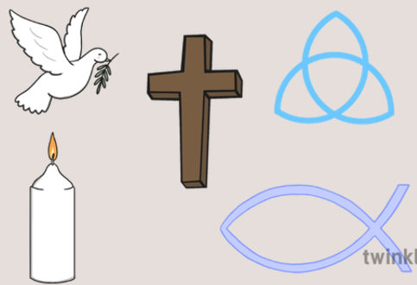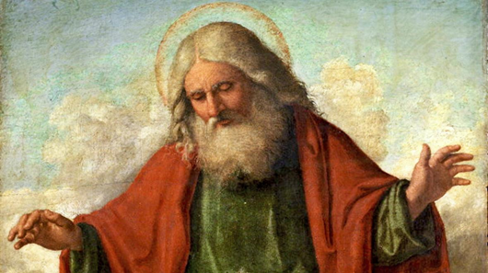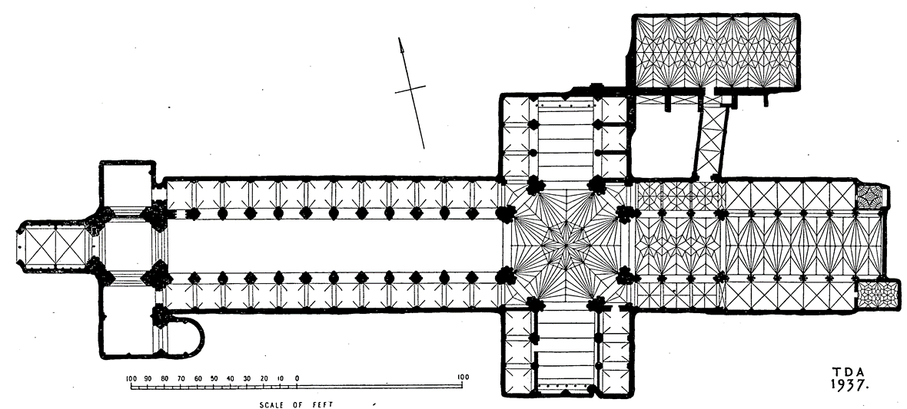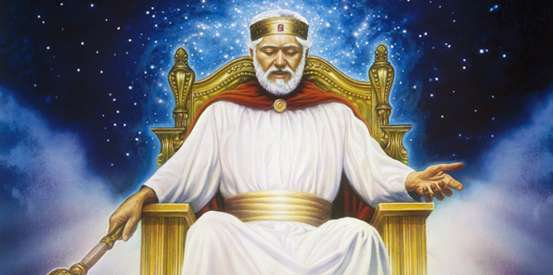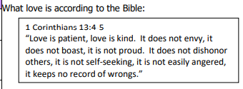

**Key questions**

* What is divine and what is Holy?
* What is God’s purpose in Christianity?
* What qualities does God need to make him special?
* What words could you use to describe God?
* How do Christians see God?
* Why do Christians like to celebrate through music?
* What is the difference between a church and a cathedral?

How do these symbols represent God?

By the end of this topic, you’ll be able to label the parts of this Cathedral

**Loving**

**That love is from God and that God is love. Christians believe that God’s love is unconditional – you can’t make god not love you.**

**Holy**

In its most basic definition, holiness means pure and set apart. As the above scriptures teach, God, in His holiness is set apart from any other god or being. He is pure. There is no wrong found in them.

Means something so special and perfect that we can’t help but love it, serve it, and tell it how wonderful it is.

**God is Holy and Loving**