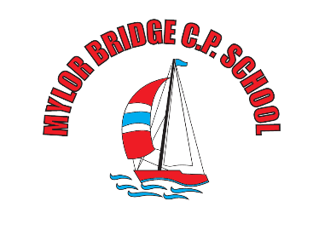
Weekly
Newsletter
email:secretary@mylor-bridge.cornwall.sch.uk
Friday 21st April 2017
Dear Parents/Carers
It has been a fantastic first week back after the Easter break, and as the new Headteacher it has been a fantastic first week in post. I would like to take this opportunity to thank all of the staff, children and parents for your very warm welcomes. I have been so impressed with the positive, friendly and helpful ethos and feel very lucky to have become part of this strong team. I am looking forward to working with each and every one of you, as we build on the great practise here at school to ensure that we are offering our pupils the very best opportunities to continue to develop in all aspects of their learning. With this this mind, I have asked the children, staff and governors to complete some simple ‘baseline’ feedback. This feedback will be really helpful for us to understand what is great about our school and what might need tweaking. I have attached a copy of this feedback sheet for parents and would really like to receive your views and opinions. Thank you for your help.

Grass Track Racing
The Year 5 children had a brilliant time at Penryn College this week – taking part in their first taste of Grass Track Racing – well done everyone.

Touch Rugby
The children took part in the first of 4 touch rugby sessions at Penryn College this week. We were very proud of the effort and resilience shown by our players and a great time was had.

Indoor Athletics
In the final sporting event of the week, 12 of our Year 6 children took part in a fantastic Indoor Athletics event at Truro School, organised by Penryn College. It is really brilliant to see so much sport happening here at school, well done to all of our competitors.

Class 3 Update
As many of you know, Mr Park has decided that he will not be returning to Class 3 – we wish him all the very best in his future endeavours. Under the Fair Recruitment process we now are advertising for a full time class teacher position, commencing after May half term, if you require more details please pop in and see me.

London Marathon – Mr Martin
Mr Martin is taking part in the London Marathon this weekend – he is number 1271 so you will be able to track him – Good luck Mr. Martin.

Brass lessons
The brass lessons re-commence on Monday 24 April with Mrs Curnow and Mrs Churcher. Please remember your brass instrument every Monday morning.

Violin Lessons
Violin lessons will commence this Friday, 28 April with Mr MacQuarrie. Please remember your violins each Friday morning.

After School Clubs
The After School Clubs will commence week beginning Monday, 24 April. Please note the revised timetable.
Monday – no After School Club – due to staff meetings.
Tuesday - KS1 Huff and Puff, £2. per session. Year 6 Homework Club, no charge. Art Club (£10 per half-term).
Wednesday –Football/Basketball/Cricket with Mr Collinge in the playground. Year 6 Rugby League at Penryn College.
Thursday – Netball/Girls Games.
Friday – Before School Running Club.

Diary Dates

Tuesday, 25 April – Year 5 – Junior Life Skills – Falmouth Fire Station.
Wednesday, 26 April – Booster swimming sessions start for 14 children; a letter and consent form has been sent home to those children.
Wednesday, 26 April – Assembly - Beach Safety talk with the RNLI.

Have a lovely weekend – enjoy the sunshine,

Mrs Vicky Sanderson – Headteacher

